A000-Eur-England-Kent-Northfleet-Clactonian-Cordiform Biface-Flint-424,000 BP-374,000 BP

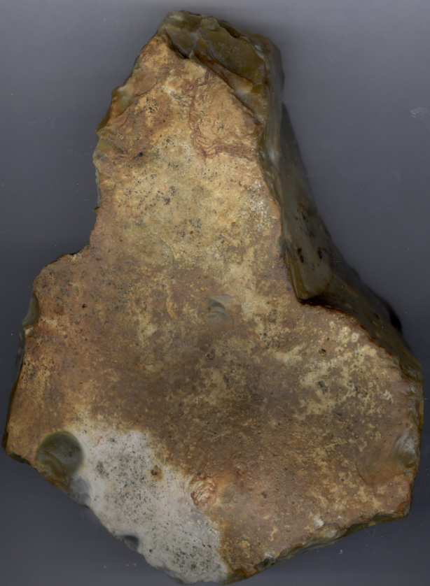 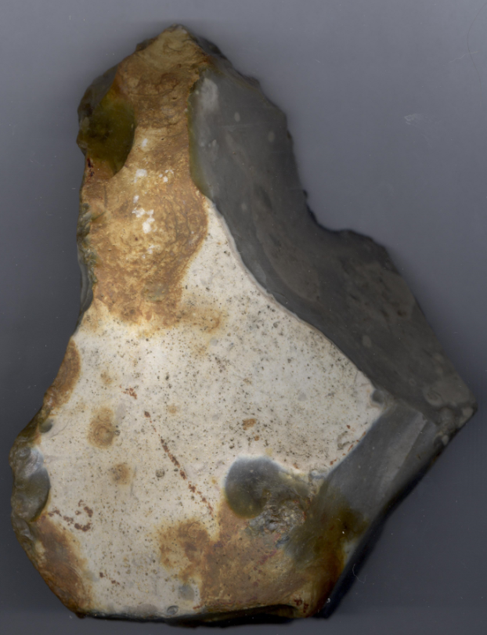

Fig. 1-2. Clactonian cordiform biface, England-Kent-Northfleet near Swanscombe

Fig. 3. A reconstruction of *Homo erectus* at the Westfälisches Landesmuseum, Herne, Germany, in a 2006 exhibition. From <https://upload.wikimedia.org/wikipedia/commons/thumb/c/cb/Homo_erectus_new.JPG/200px-Homo_erectus_new.JPG>

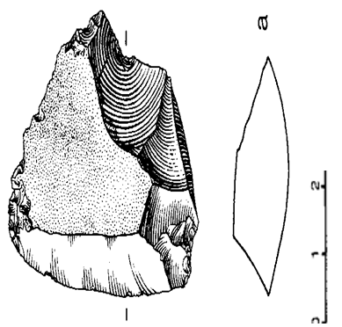

Fig. 4. Cordiform biface with classic Clactonian flaking fromEast Farm, Barnham, Suffolk,from Aston *et alii* 1994.

**Formal Label:** England-near Swanscombe, Kent-Clactonian Biface-424,000 BP-374,000 BP

**Display description:**

This Clactonian cordiform biface was made by *Homo erectus* in the early Hoxnian Interglacial, (Marine Isotope Stage 11, 424,000 BP-374,000 BP (Lisiecki and Raymo 2005; Stringer 2006) and probably was used in the butchering of Pleistocene animals including the straight-tusked elephant *(Palaeoloxodon antiquus*) (Glass 2016) and the giant hippopotamus, (Hippopotamus amphibius) (Schreve 2009**;** Tester 1984) which were in the area where this tool was found. Clactonian refers to the flint tools originally found in a paleo-channel at Clacton-on-Sea in Essex, England, in 1911 by S. H. Warren (Warren 1922). The present tool was found west of Northfleet, near the destroyed flint quarries of Barnfield Pit and Rickson's Pit, Swanscombe, Kent County, England, previously noted for their Clactonian artifacts (Conway et alii 1996).

**Accession Number:**

**LC Classification:** GN772.22.G7

**Date or Time Horizon:** 424,000 BP-374,000 BP

**Geographical Area:** Northfleet near Swanscombe, Kent

**Map, GPS Coordinates:** 51.44107 0.33694; 40° 26' 46" N 79° 58' 56" W

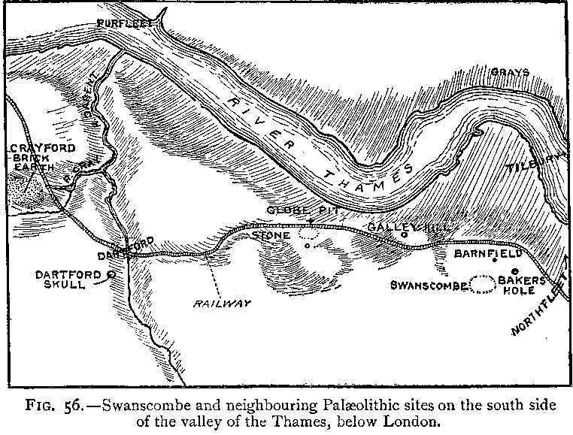 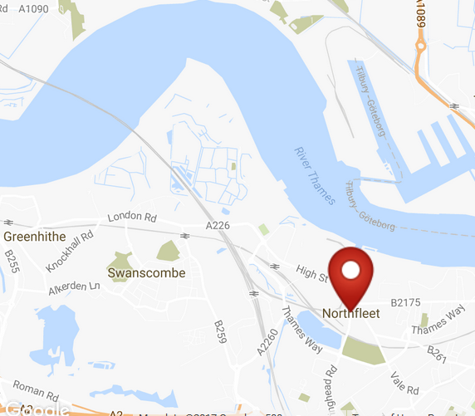

Fig. 4. “Swanscombe and neigbouring Palaeolithic sites on the south side of the valley of the Thames, below London,” (Keith 1916).’

Fig. 5. Map of Northfleet. From http://latitude.to/img/latitude-logo.svg.

**Cultural Affiliation:** Lower Paleolithic, Clactonian

**Medium:** Flint

**Dimensions: H 18 cm; W 11 cm  
Weight:**

**Provenance: Old English collection from 1920’s**

**Condition:** original, with ancient patination.

**Discussion:** This Clactonian biface, 424,000 BP-374,000 BP, found near Swanscombe, Kent, has been made on a thick and heavy flint flake from a large nodule tapering toward the distal end. A heavy hammer struck a bulb of percussion on the two lateral sides, creating deep ripples. Clactonian bifaces that are in the same general cordiform shape as Acheulian bifaces retain their classic Clactonian flint working, that is, with large bulbs of percussion and without thinned, lateral, sharp cutting edges. This specimen derives from a time-horizon when Clactonian flake tool production came into contact with Acheulian tool production. It would seem that this Clactonian biface is a blend of two cultures: it has a simple bilateral symmetry with two opposing bulbs of percussion to form a robust distal point, and it has two blubs of percussion to form the proximal end to enable grasping by the hand. The result of a crude cordiform shape simulating the Acheulian cordiform pattern but without any thinning or shaping. Consequently, the biface has the remnants of an ancient cortex.

Since this Clactonian biface exhibits the general cordiform shape of Acheulian bifaces, it may be culturally distinct but not technologically distinct. That is, *Homo erectus* may have been working flint at the same time horizon (ca 400,000 BP) as the Acheulian flint workers (Oxygen Isotope Stage 11, Bowen 1989; Ashton et alii 1994), which suggests a complex hominin dynamic that influenced the choice of the general type of flint industry. That is, the cordiform shape was produced to mimic the Acheulian cordiform shape but with the Clactonian technology. Similarly, the choice of raw material appears to have been chosen on the basis of end use, which affected the selection of the quality and quantity of flint available. In this case, too, the Clactonian flint workers chose a flint similar to that of the Acheulian flint workers. This suggests that hominin behavior was not as constrained by a biologically-driven cultural framework as it was by a technological one, albeit that the Clactonian flint workers did not apprehend the Acheulian flint-working technology.

**References:**

Ashton, Nick, McNabb, John, Irving, Brian, Lewis, Simon and Parfitt, Simon (1994) Contemporaneity of Clactonian and Acheulean flint industries at Barnham, Suffolk Antiquity, 68, (260), pp. 585-589.

Conway, Bernard, John McNabb and Nick Ashton, eds. 1996. *Excavations at Barnfield Pit,* *Swanscombe, 1968-72*; illustrations by Phil Dean. London: Dept. of Prehistoric and Romano-British Antiquities.

Darvill, J. 2017. Pers. comm. 30 Jan. 11, ME19 5LH, UK.

Glass, Helen. 2004. “Stone Age elephant remains found,” BBC News, 19 June. <http://news.bbc.co.uk/2/hi/uk_news/england/kent/3821527.stm>. Retrieved 1 Feb 2017.

Keith, Arthur. 1915. *The Antiquity of Man*. London.

Lisiecki, Lorraine E. and Maureen E. Raymo. 2005. ["A Pliocene-Pleistocene stack of 57 globally distributed benthic δ18O records"](http://www.lorraine-lisiecki.com/LR04_MISboundaries.txt). <http://www.lorraine-lisiecki.com/LR04_MISboundaries.txt>. Retrieved 1 Feb 2017.

## McNabb, John. 2007. *The British Lower Palaeolithic: stones in contention*. London, New York: Routledge.

# Schreve, Danielle C. 2009. “A new record of Pleistocene hippopotamus from River Severn terrace deposits, Gloucester, UK—palaeoenvironmental setting and stratigraphical significance,” *Proceedings of the Geologists' Association*, 120 (1): 58–64.

Stringer, Chris. 2006. Homo Britannicus: The incredible story of human life in Britain. London: Penguin.

Tester, P. J. (1984). "Clactonian Flints from Rickson's Pit, Swanscombe," Archaeologia Cantiana, Kent Archaeological Society. Retrieved 1 Feb 2017.

Warren, S. H. 1922. “The Mesvinian Industry of Clacton-on-Sea,” Proceedings of the Prehistoric Society of East Anglia

ASH'I'ON, N.M., J. COOK, S.G. LEWIS & J. ROSE (ed.). 1992.

High *Lodge: excavations by G. de G. Sieveking 1962-*

*68 a n d J . Cook 1988.* London: British Museum Press.

ASHTONN, .M. & J. MCNABB1. 992. The interpretation and

context of the High Lodge industries, in N. Ashton *et*

*a].* 1992: 164-8.

BOWEND, .Q., S. HUGHESG, .A. SYKES& G.H. MILLER1. 989.

Land-sea correlations in the Pleistocene based on

isoluecine epimerisation i n non-marine molluscs,

*Nature* 340: 49-51..

MCNABBJ,. 1992. The Clactonian: British Lower Palaeolithic

flint technology in biface and non-biface assemblages.

Unpublished Ph.D thesis, London University.

PATERSONT,. T. 1937. Studies in the Palaeolithic succession

in England. No. 1: the Barnham sequence, *Proceedings*

of *the Prehistoric Society* of *East Anglia* **3 :**

87-135.

ROBERTSM, .B. 1990. Amey's Eartham pit, Boxgrove, in C.

Turner (ed.), *SEQS: the Crorner Symposium, Norwich*

*1990, field excursion guide book* 62-77. Cambridge:

SEQS.

ROE, D.A. 1981. *The Lower and Middle Palaeolithic periods*

*in Britain.* London: Routledge & Kegan Paul.

WYMERJ,. J. 1985. *Palaeolithic sites* of *East Anglia.* Norwich:

Geo Books.